Step 1

Go to Control Panel

Step 2

Program and Features

Step 3

Turn windows features on or off

Step 4

Select Internet Information Services and select the following checked items

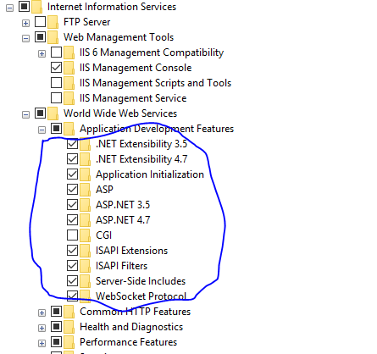

Step 5

Open IIS

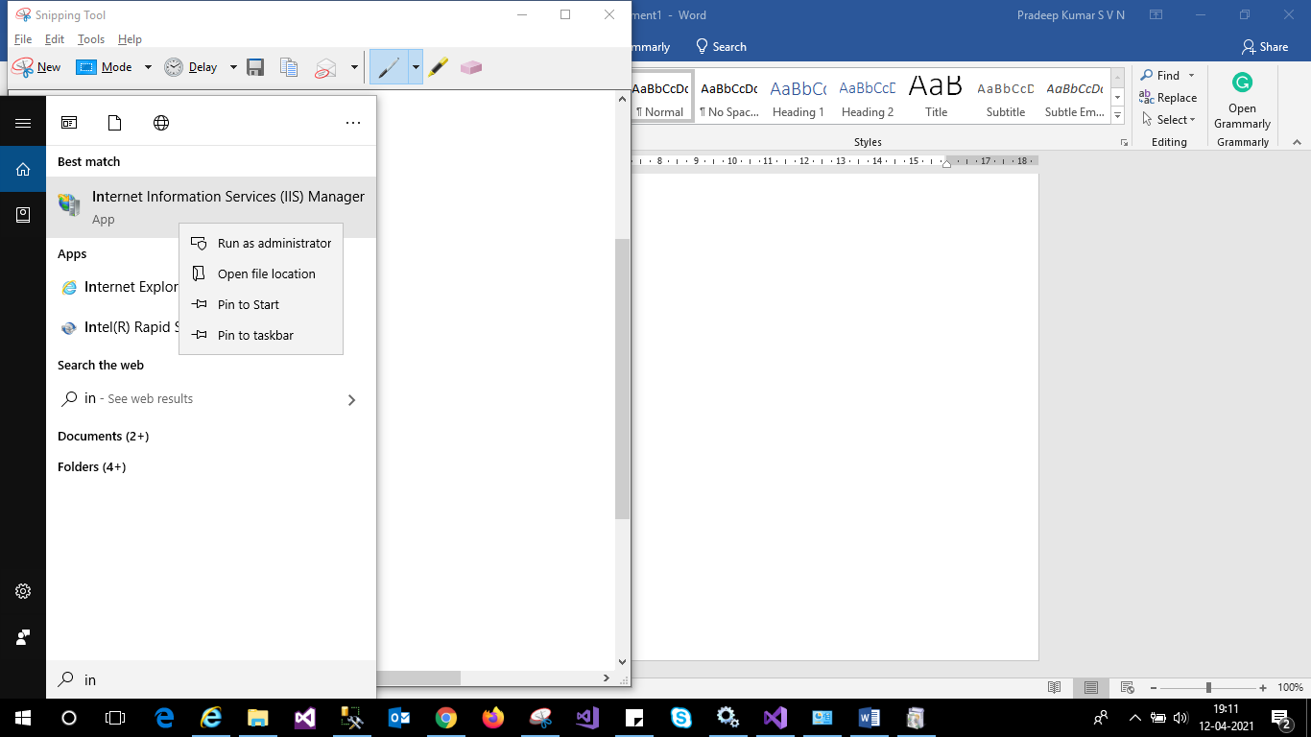

Step 6

Create Application Pool

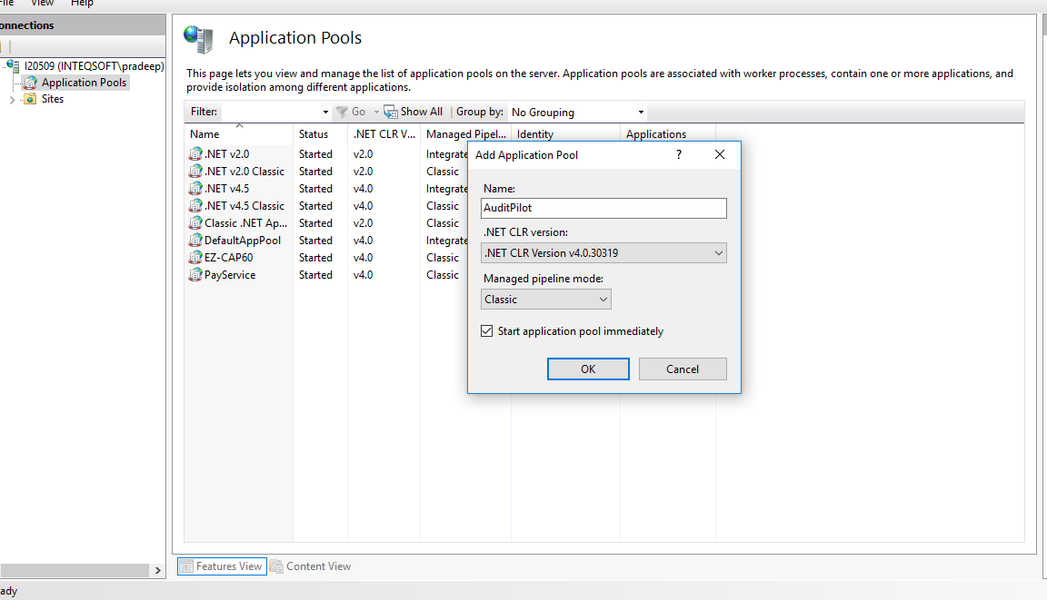

Note : application pool should the user specified who has the access to the database used by application

To set that user in the application pool, click on the advance setting in right panel on selecting the application pool

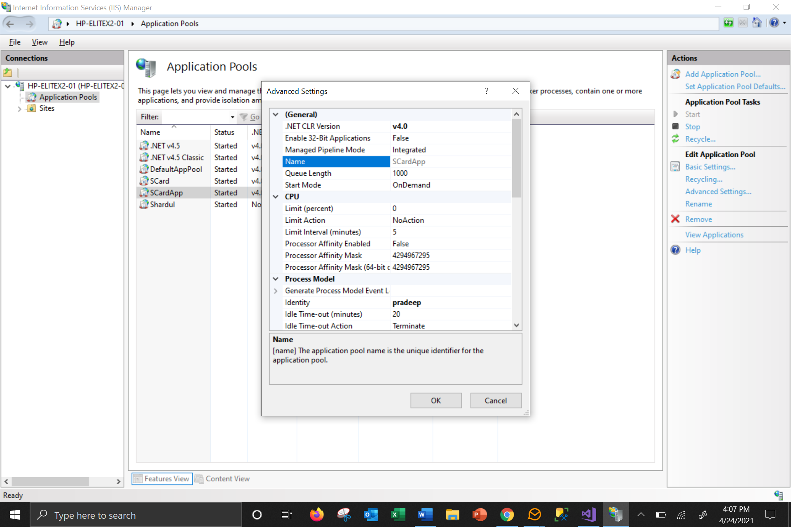

Under the Process Model section of Advance Settings of Application Pool specify the user that has the DB access

Step 7

Copy the packages from Gitbhub to a location of the server

Ex : C:/AuditPilot

Step 8

Create an Application in IIS under Default Web site

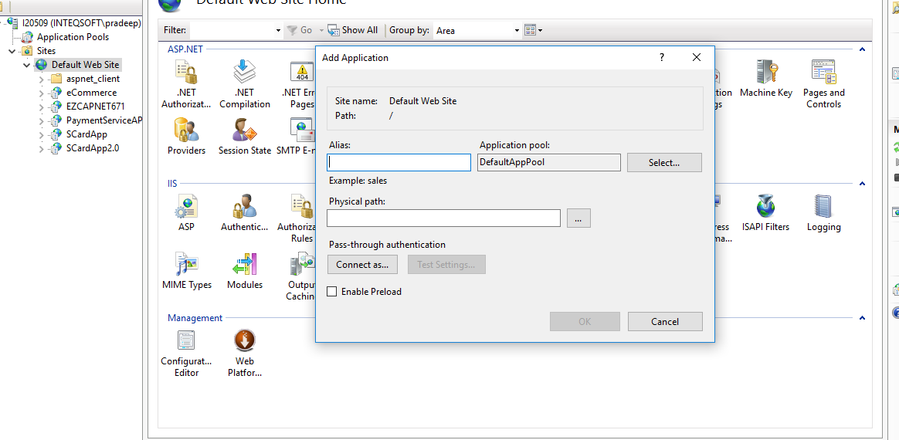

Please select application pool that is created in Step 6

Select the folder (Physical Path: C:/AuditPilot) where the package is copied in Step 7

Step 9

Open SQL Server in Management Studio , connect to DB server

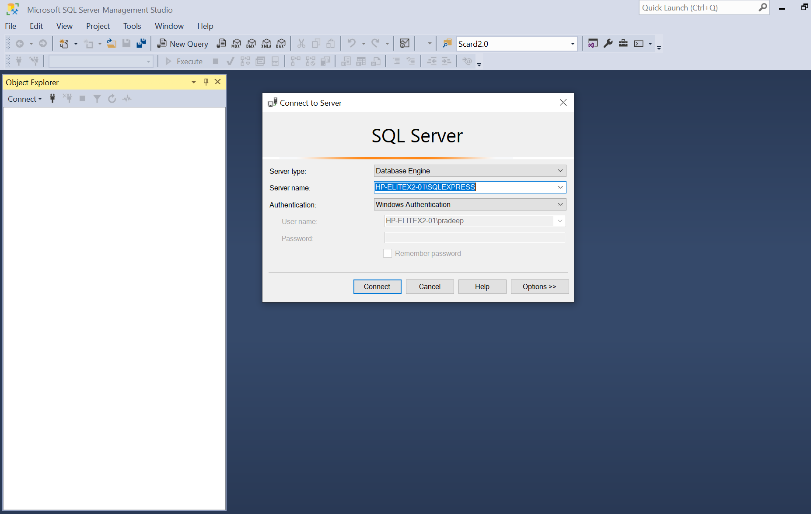

Open New Query

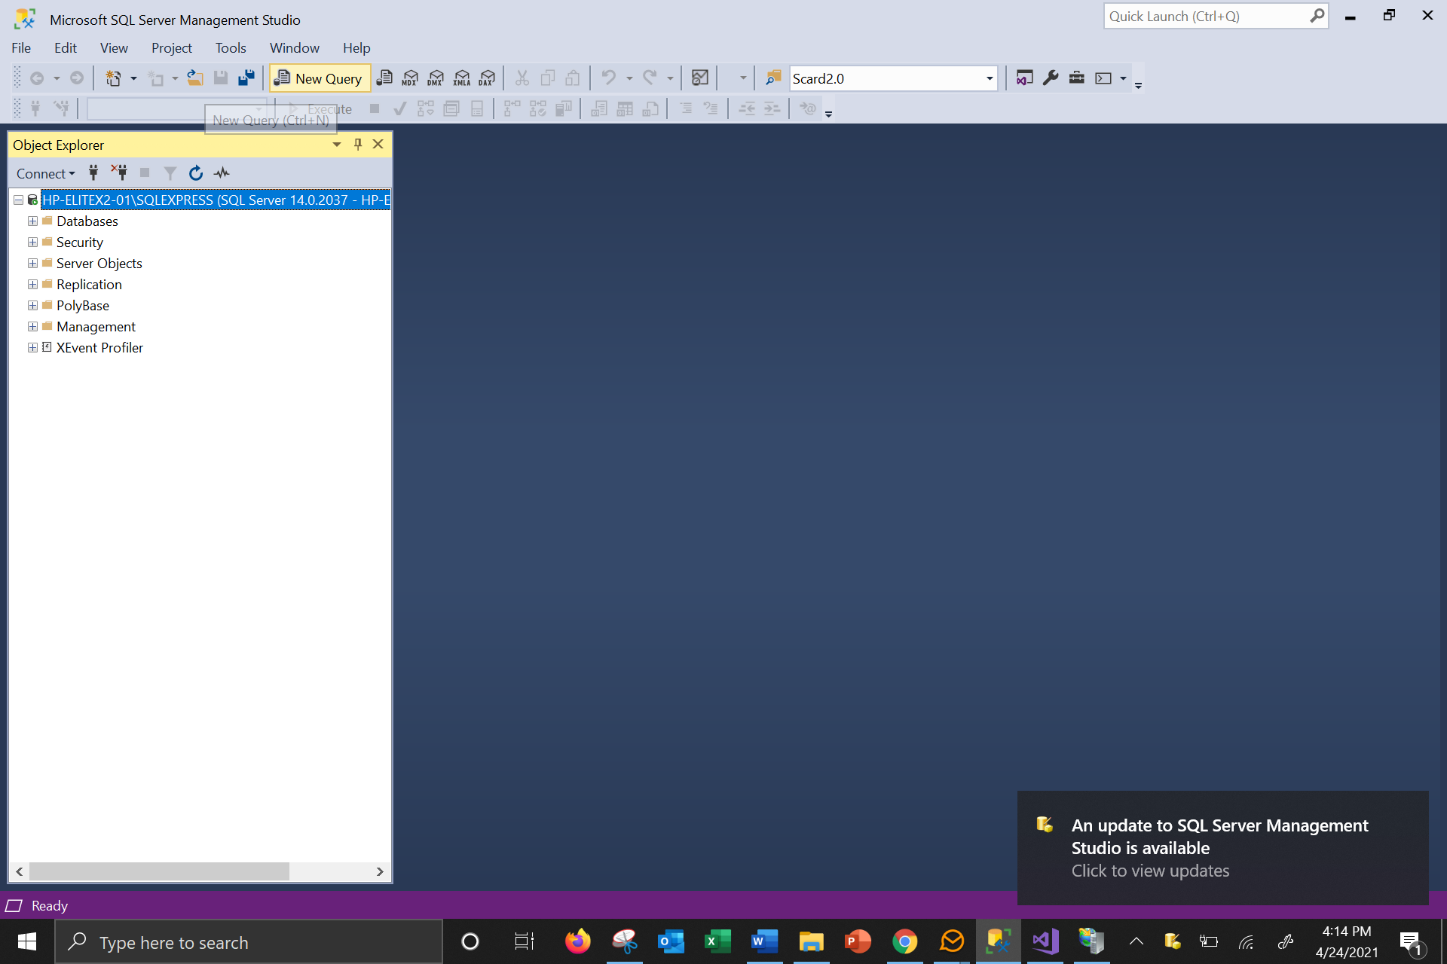

Step 10

Unzip “DM Script V1.0.2_Upd.zip” will see DM Script V1.0.2_Upd.sql open in Query window of SQL Server on the database that is connect in Step 9

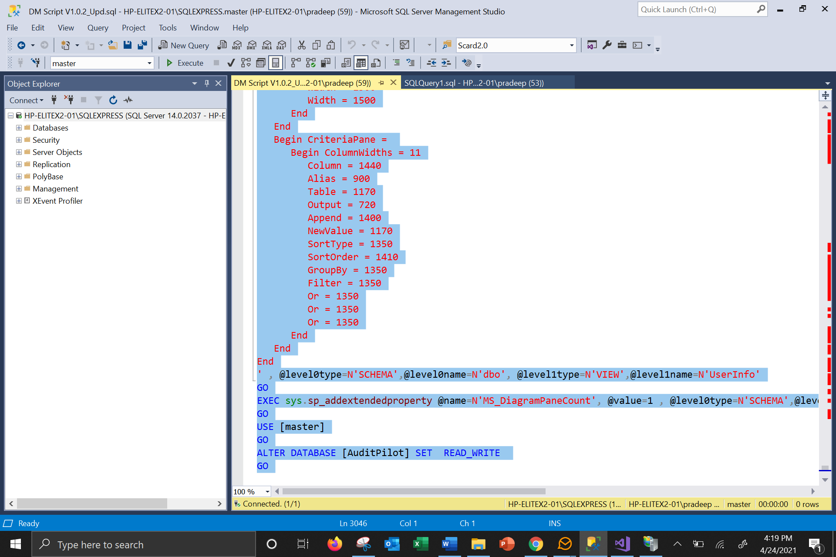

Step 11

Select all the Script using Ctrl + A and click on Execute the Script by clicking “Execute ”

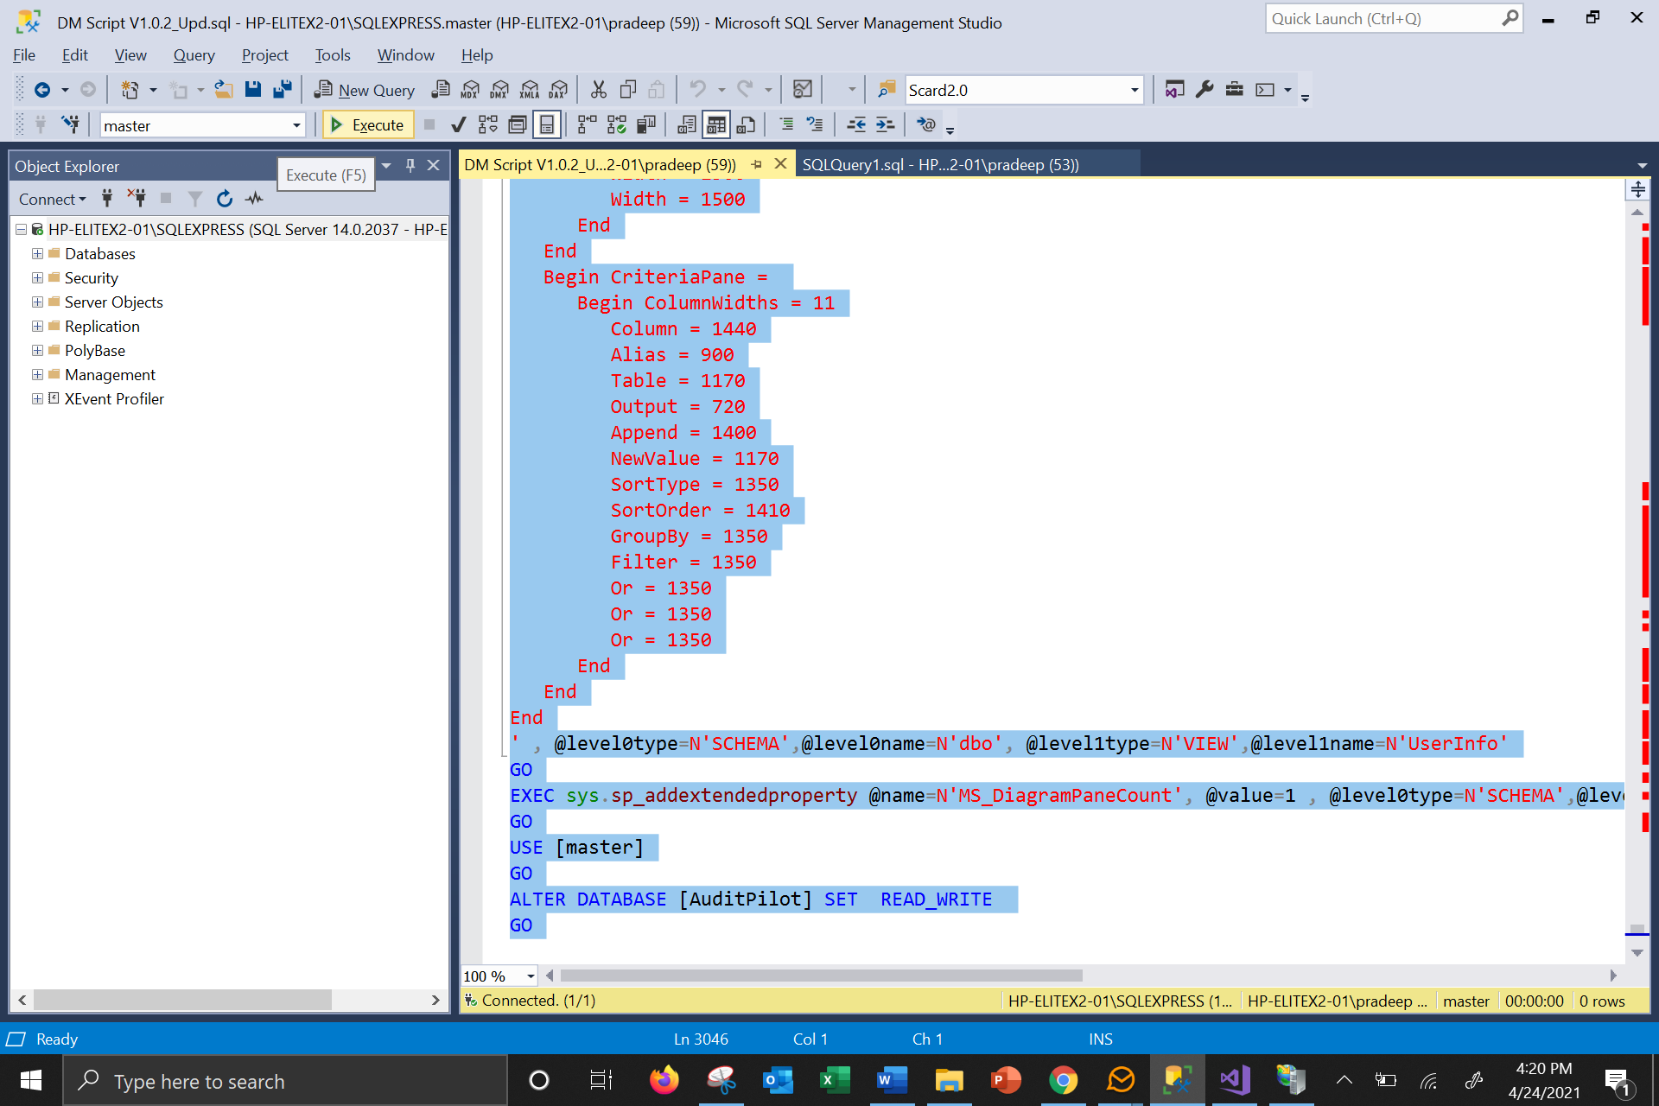

Step 12

Database will show the successful creation message as

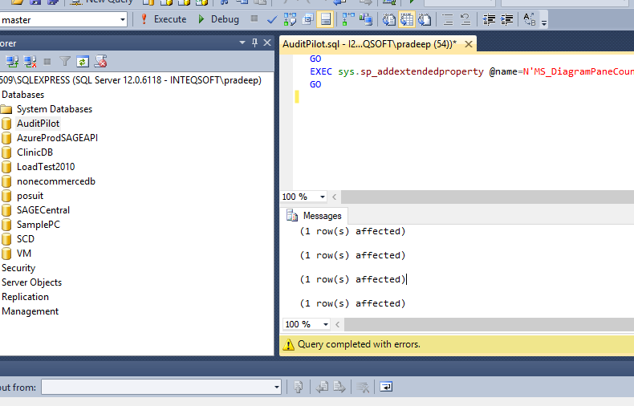

Step 13

Verify the database creation successful by click the Database name and tables

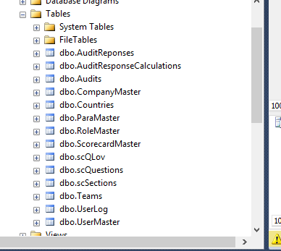

Note : Any table missing in the above list means DB creation failed , send the screen shot of the created tables dev team will fix the error and guide in deployment

Step 14:

Open Web.Config in the folder created in Step 7

Ex: C:\AuditPilot

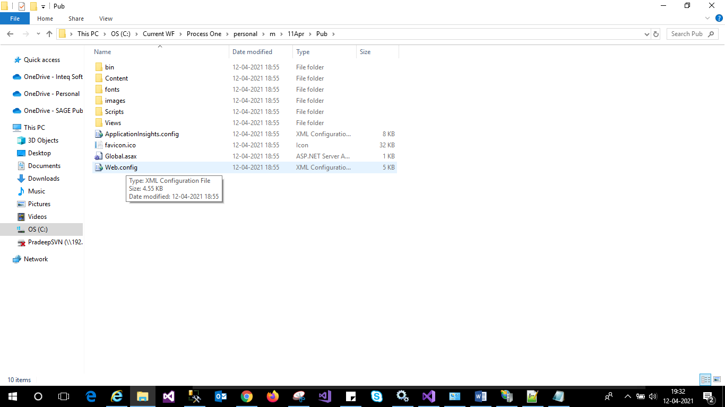

Find the below tags

<connectionStrings>

    <add name="constr" connectionString="Data Source=LAPTOP-08OQDGIF\SQLEXPRESS; Integrated Security=true;Initial Catalog=Scorecard; uid=sa; Password=sql@123; " providerName="System.Data.SqlClient"/>

  </connectionStrings>

Change the data source name to the name of the database created in Step 9, please make sure the data source contains fully qualified server name

Change the database name to the name that is specified in Step 9

Specify UI i.e. user name used for connecting to database

Specify password used for connecting to database

Note : during product these will be in encrypted format will not be as plain text

Save the web.Config file

Step 15

Restart the server

Step 16

Browse <http://localhost/AuditPilot> in browser it will open Login page